Edith F. (Smith) Schrock
April 15, 1885 – September 8, 1970

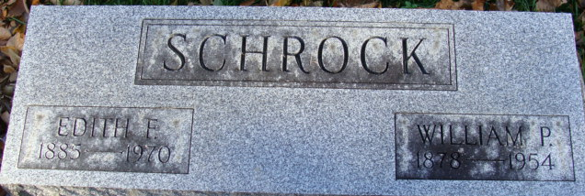
Photo of Alicia Kneuss

Edith Schrock Dies After Long Illness

Mrs. Edith F. Schrock, 85, of 225 South Second Street, a lifelong resident of Decatur, died at 1:45 p.m. Tuesday at the St. Anne Home in Fort Wayne. She had been in failing health for the past three years. She was born in Decatur April 15, 1885, a daughter of A.J. and Alwilda F. Fonner-Smith and was married to William P. Schrock Oct. 12, 1912. Her husband preceded her in death Dec. 29, 1954.
Mrs. Schrock was a member of the First Presbyterian Church and the Associate Chapter of the Psi Ota Xi Sorority.
Surviving is one daughter, Mrs. A. W. (Janet) Kettler, Jr., of Fort Wayne; one son, William A. Schrock of Decatur, and one grandson, Andrew Kettler.
Funeral services will be conducted at 1:30 p.m. Thursday at the Zwick Funeral Home, with Rev. Robert E. Vander Hart officiating. Burial will be in the Decatur Cemetery. Friends may call at the funeral home from 2 to 4 and 7 to 9 p.m. today.
Preferred memorials are to the First Presbyterian Church memorial fund.

Decatur Daily Democrat, Adams County, Indiana
Wednesday, September 9, 1970

