Agnes Julia Schrock
August 6, 1882 – October 30, 1906

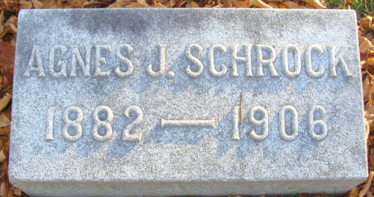
Photo by Alicia Kneuss

HAD BEEN ILL SIX MONTHS
But Friends Were Hoping For Her Recovery Until Yesterday
Butler, Ind., Oct. 30
J. C. Patterson. Decatur, Ind.
"Agnes fell asleep in Jesus, oh, so sweetly, at twelve o'clock.
G. H. MYERS."
The above message received here at one o'clock this afternoon, tells a story that has saddened the hearts of nearly every citizen of Decatur. It means that Miss Agnes is dead. One of the fairest and loveliest young ladies of this community, one whom everyone adored and loved, one whose life has been an open book, whose years have been filled with kind acts and Christian teachings, has been taken from us. It is hard to believe, and while all our hearts are sad, we can but sympathize with broken hearted mothers, sisters and brothers.
Miss Agnes' illness dates back six months when she suffered an attack of typhoid fever. The disease was slow but persistent and the efforts of several physicians proved futile. After four months her condition improved slightly but the fever could not be broken. She was taken to Rome City and gained strength, though very slowly. After her return here she seemed to improve slightly and her friends and relatives hoped for her ultimate recovery. Two weeks ago Mrs. Schrock accompanied Agnes to Butler for a visit with Rev. Myers and family, and from day to day encouraging news was heard until yesterday morning when the first message announcing a turn for the worse came.
During yesterday afternoon she regained consciousness and was able to recognize those who gathered at her bedside. All her brothers and sisters including Miss Bessie and Will, from this city, Robert, of Crawfordsville, and Miss Nellie of Indianapolis arrived in time to talk to her. At 8:30 last night she again lapsed into unconsciousness and slept peacefully until her death at noon today.
The sad news flashed from lip to lip, here and everywhere were heard the sincerest expressions of sorrow. In the entire city there was no one more popular, and there are many sad hearts today.
Miss Agnes had just passed her twenty-fourth birthday, and had spent her entire life in Decatur. She was a graduate of the high school and was a talented and accomplished young lady. For several years she has held a responsible position at the Old Adams County bank, and the officers of that institution speak in the highest terms of her ability.
The remains will probably arrive here on the 1:19 train over the G. R. & I. tomorrow afternoon, and the funeral will be held from the house at ten o'clock Thursday morning.
Several physicians will conduct a post mortem examination this evening to ascertain the exact cause of death and Drs. Beaver and Coverdale of this city will likely attend.

Decatur Democrat, Adams County, Indiana
A weekly newspaper
Thursday, November 1, 1906

**
Indiana, Death Certificates, 1899-2011
Name: Julia Agnes Schrock
Gender: Female
Race: White
Age: 24
Marital status: Single
Occupation: bookkeeper
Birth Date: 6 Aug 188? (missing last number)
Birth Place: Decatur Ind
Death Date: 30 Oct 1906
Death Place: De Kalb, Indiana, USA
Father: Wm H Schrock
Mother: Maragritia Patterson?
Informant: U. P. Schrock; Decatur, Indiana
Burial: doesn't list place

