Nettie (Blew) Schrank
June 12, 1862 – August 22, 1915

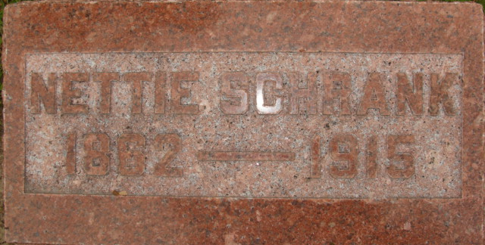
Photo by Alicia Kneuss

Nettie Schrank
in the Indiana, U.S., Death Certificates, 1899-2017
Name Nettie Schrank
[Nettie Blew]
Gender Female
Race White
Age 53
Marital Status Married
Birth Date 12 Jun 1862
Birth Place Ohio
Death Date 22 Aug 1915
Death Place Decatur, Adams, Indiana, USA
Death Registration Date 1910 - 1919
Father John Blew
Mother Unknown
Spouse Ben Schrank
Informant Ben Schrank; Decatur, Indiana
Burial: August 24, 1915; Decatur Cemetery

**
Indiana, U.S., Marriages, 1810-2001
Name Jennettie Blew
Gender Female
Race White
Event Type Marriage Registration (Marriage)
Marriage Date 3 Mar 1891
Marriage Place Decatur, Indiana, United States
Residence Place Decatur
Father Jacob Blew
Mother Jane Stacy
Spouse Bennett Schrank
Page 222

