Howe Bennett Schrank
August 28, 1865 – October 5, 1932

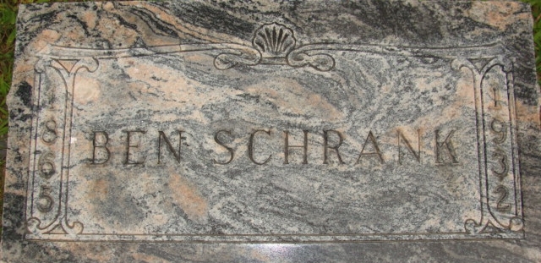
Photo by Alicia Kneuss

Howe Bennett Schrank
in the Indiana, U.S., Death Certificates, 1899-2017
Name Howe Bennett Schrank
Gender Male
Race White
Age 67
Marital Status Married
Birth Date 28 Aug 1865
Birth Place Indiana
Death Date 5 Oct 1932
Death Place Decatur, Adams, Indiana, USA
Death Registration Date 1932
Father John Schrank
Mother Mary Snedker
Spouse Amelia
Informant: Mrs. Ben Schrank; Decatur, Indiana
Burial: October 8, 1932; Decatur Cemetery

