Amelia Sophia (Schraluka) Schrank
March 19, 1878 – December 12, 1953

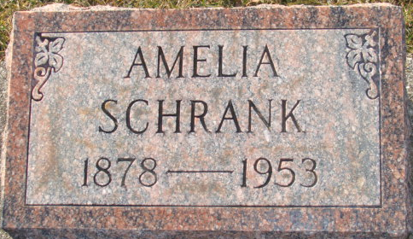
Photo by Alicia Kneuss

Sophia Schrenk
in the Indiana, U.S., Death Certificates, 1899-2017
Name Sophia Schrank
[Sophia Schralka]
Gender Female
Race White
Age 76
Marital Status Widowed
Birth Date 19 Mar 1877
Birth Place Adams County Indiana
Death Date 12 Dec 1953
Death Place Fort Wayne, Allen, Indiana, USA
Death Registration Date 1953
Father William Schralka [sic - Shraluka]
Mother Louise Lindeman
Informant Helen Casselman; daughter; Fort Wayne, Indiana
Burial: December 15, 1953; Maplegrove Cemetery; Decatur, Indiana
**
Amelia Sophia Schralaka in Donna Kay Beals Family Tree
Spouse Ben Schrank
Father William Frederick Schraluka
Mother Sophia Elizabeth Lindemann
Children Helen Florine
Birth 19 Mar 1878 Adams, Indiana, USA
Death 12 Dec 1953
Residence 1900 Huntington, Huntington, Indiana, USA

