Irene A. (Eckrose) Schram
December 26, 1898 – January 28, 1968

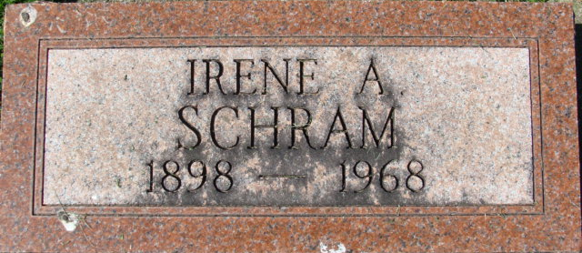
Photo by Alicia Kneuss

Irene Schram
in the Indiana, U.S., Death Certificates, 1899-2017
Name Irene Schram
[Irene Eckrose]
Gender Female
Race White
Age 69
Marital Status Widowed
Birth Date abt 1899
Birth Place Michigan
Death Date 28 Jan 1968
Death Place Decatur, Adams, Indiana, USA
Death Registration Date 1968
Father John Eckrose
Mother Anna Matson
Informant: Mrs. Tom Lutes; niece; Decatur, Indiana
Burial: January 30, 1968; Decatur Cemetery; Decatur, Indiana
**
U.S., Social Security Death Index, 1935-2014
Name Irene Schram
Social Security Number xxx
Birth Date 26 Dec 1898
Issue year Before 1951
Issue State Michigan
Last Residence 46733, Decatur, Adams, Indiana, USA
Death Date Jan 1968

