William F. Schraluka
April 6, 1872 – September 27, 1941

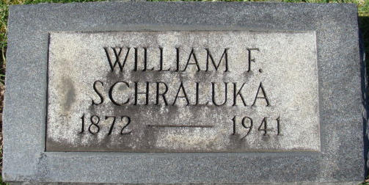
Photos by Alicia Kneuss

SHRALUKA [sic] RITES HERE TUESDAY
William Shraluka Dies Saturday Afternoon At Hospital
Funeral services for William Shraluka, 67, of this city, who died Saturday afternoon at the Adams County Memorial Hospital, will be held Tuesday afternoon. The services will be held at the First United Brethren Church of which he was a member at 2 p.m. Burial will be in the Decatur Cemetery. The Rev. G. T. Rosselot will officiate.
Death was attributed to a heart ailment after an illness of about two weeks. He was admitted to the hospital at that time, suffering from pneumonia.
The deceased was born in Magley on April 6, 1874, the son of William and Sophia Shraluka. He had resided in this city about 50 years. For a number of years he was employed by the Indiana Service Corporation and later worked as a laborer in this city. He was never married.
Surviving are four sisters, Mrs. Louise Shraluka[sic] of this city, Mrs. Minnie Cook of Cardwell, Missouri; Mrs. Sophia Smith and Mrs. Amelia Shrank, also of Decatur. Two sisters are deceased.
The body may be view at the Gillig & Doan Funeral Home until time for the services.

Adams County, Indiana Historical Museum
1941B January - December Scrapbook, image 109, 114
Handwritten date: September 27, 1941

