Louise Bernadine Schraluka
January 4, 1867 – June 2, 1952

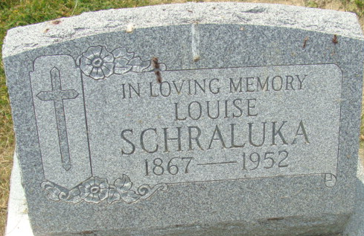
Photo by Alicia Kneuss

SHRALUKA RITES ARE HELD TODAY
MRS. LOUISE B. SHRALUKA, GRANDMOTHER OF SHERIFF, DIES

Mrs. Louise Bernadine Shraluka, 85, grandmother of Sheriff Robert Shraluka, did at 8:30 o’clock Monday evening at the Lawton Rest Home in Fort Wayne, following an illness of two years.
She was born in Kirkland Township Jan. 4, 1867, a daughter of William and Amelia Schraluka, and was a lifelong resident of Adams County and Decatur until her illness.
Surviving is a son, Bart W. Shraluka of Fort Wayne; a sister, Mrs. Ben Shrank of Fort Wayne; two grandchildren, Robert Shraluka and Mrs. Jerome Meyer, both of Decatur, and three great-grandchildren.
Private funeral services were held at 10 o’clock this morning (missing).

Adams County Historical Museum, Adams County, Indiana
May 1952 – March 1955 Scrapbook, image 17
Handwritten date: Wednesday, June 4, 1952
**
Indiana, U.S., Death Certificates, 1899-2017
Name Louise Bernadine Shraluka
Gender Female
Race White
Age 85
Marital Status Single
Birth Date 4 Jan 1867
Birth Place Kirkland Twp, Indiana
Death Date 2 Jun 1952
Death Place Fort Wayne, Allen, Indiana, USA
Death Registration Date 1952
Father William Shraluka
Mother: Unknown
Informant: Robert Shraluka; Decatur, Indiana
Burial: June 4, 1952; Maplewood Cemetery; Decatur, Indiana

