Robert L. Schrader
1951 – July 30, 1968

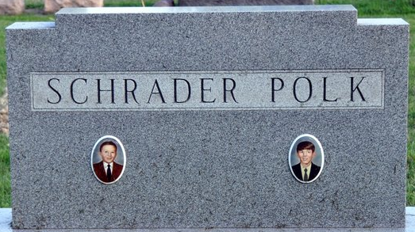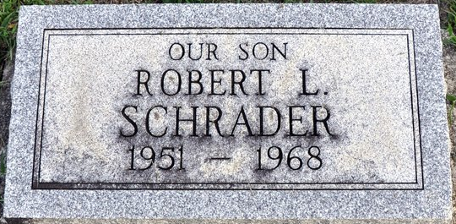
Photo by Deb Curry

Robert L Schrader
in the Ohio, U.S., Death Records, 1908-1932, 1938-2022
Name Robert L Schrader
Gender Male
Race White
Marital Status Not married (Married)
Death Age 16
Birth Date Abt 1952
Death Date 30 Jul 1968
Death Place Cleveland, Cuyahoga, Ohio, USA
Certificate Number 051851
Inquest Hospital Cleveland Clinic Hospital
Inquest Questions Certifier: Physician; Autopsy Performed?: Yes, Unknown If Used For Certification;

