Mary Eva (Polk) Schrader
August 13, 1932 – January 7, 2009

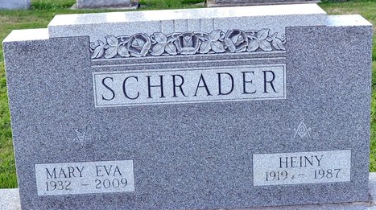
Photo by Deb Curry

Mary E. Schrader, 76 of Fortville, Indiana formerly of Decatur where she had lived before moving to Fortville in 1998 died Wednesday, January 7, 2009 at Hancock Regional Medical Center in Greenfield, Indiana. She was born August 13, 1932 in Cloverport, Kentucky to the late John A. Polk and Stella (Stiles) Polk Waller. Mary married Heiny Schrader on March 2, 1950 and he died April 25, 1987.
She is survived by a brother Rev. Frank (Mary) Bosler of Busan, South Korea; a sister Betty (Arthur) Estes of Ingalls, Indiana; 3 nieces and 3 nephews, 2 great nephews, 3 great nieces and 2 great great nieces. She is preceded in death by 2 sons John F. Schrader in 1963 and Robert L. Schrader in 1968.
Mary was a former member of the First Baptist Church in Decatur, the Faith Shrine of Fort Wayne #29 and the Decatur Order of Eastern Star #127.
Funeral services will be held at 2:00 p.m. Monday, January 12, 2009 at Haggard & Sefton Funeral Home with calling from Noon-2:00. Rev. Whitney West will be officiating and burial will be in Decatur Cemetery.
Memorials are to First Baptist Church.

Haggard – Sefton & Hirschy Funeral Home, Adams County, Indiana
January 8, 2009

**
Indiana, U.S., Death Certificates, 1899-2017
Name Mary E Schrader
Maiden Name Polk
Gender Female
Race White
Age 76
Marital Status Widowed
Birth Date 13 Aug 1932
Birth Place Cloverport, Kentucky
Death Date 7 Jan 2009
Death Place Greenfield, Hancock, Indiana, USA
Death Registration Date 2009
Father John A Polk
Mother Stella Stiles
Informant: Betty Estes; sister; Ingalls, Indiana
Burial: January 9, 2009; Decatur Cemetery; Decatur, Indiana

