John Fritz Schrader
July 10, 1956 – June 15, 1963

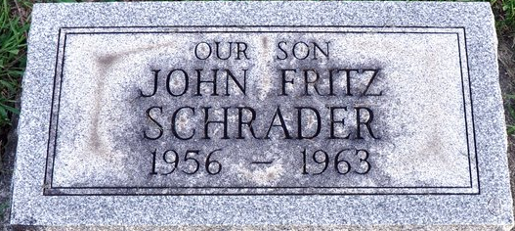
Photo by Deb Curry

Rites Thursday for Drowning Victim

Funeral services will be held Thursday for John Fritz Schrader, six-year-old Decatur boy who was drowned last Saturday afternoon while swimming in Woods Reservoir near Winchester, Tenn. Services will be held at 2 p.m. Thursday at the First Baptist Church, with the Rev. Robert E. McQuaid officiating, and burial will be in the Decatur Cemetery. Friends may call at the Winteregg-Linn Funeral Home after 7 o’clock this evening and 12 noon Thursday, after which the body will lie in state at the church until time of the services.
The boy was born in Tell City on July 10, 1956, the son of Henry and Mary Eva Polk-Schrader. The family moved to this city while the father was serving as foreman on construction of the two new city water towers. They reside at 653 Mercer Avenue.
After school last month the family went to Tennessee to be with the father while engaged in construction work.
Mrs. Schrader, who was riding in the ambulance with her son who was being rushed to a hospital, suffered a crushed vertebra in her spine when the ambulance was involved in a traffic accident. She will be confined to the hospital for at least six weeks.
The drowning victim is survived by his parents; one brother, Robert Louis Schrader, at home, and the grandparents, Mr. and Mrs. Fred Schrader of Phoenix, Ariz., Mrs. Stella Waller of Engle, and John Polk of Decatur.
The boy was a member of the First Baptist Church.

Berne Library Heritage Room, Adams County, Indiana
Obits 1962-1964
Handwritten date: Tuesday, July 9, 1963

**
Tennessee, U.S., Death Records, 1908-1965
Name John Fritz Schrader
Gender Male
Race White
Age 6
Birth Date 10 Jul 1956
Birth Place Indiana
Death Date 15 Jun 1963
Death Place Estill Springs, Route 2, Franklin, Tennessee, USA
Father Heiny Schrader
Mother Mary Eva Polk
Informant Heiny Schrader; Estill Springs, Tennessee
Removal: Decatur, Indiana
Certificate Number 17072

