Heiny Schrader
April 22, 1919 – April 24, 1987

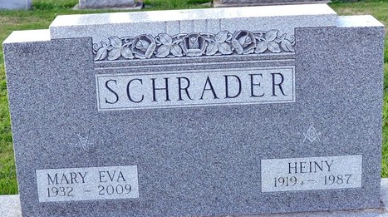
Photo by Deb Curry

Heiny Schrader
in the Indiana, U.S., Death Certificates, 1899-2017
Name Heiny Schrader
Gender Male
Race White
Age 68
Marital Status Married
Birth Date 22 Apr 1919
Birth Place Ohio
Death Date 24 Apr 1987
Death Place Decatur, Adams, Indiana, USA
Death Registration Date 1987
Father Fred Schrader
Mother Clara
Spouse Mary Polk
Informant Mary Schrader; wife; Decatur, Indiana
Burial: April 27, 1987; Decatur Cemetery; Decatur, Indiana

