Fred Schrader
August 24, 1888 – April 30, 1964

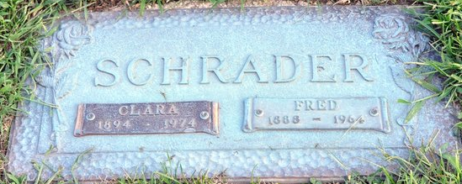
Photo by Deb Curry

Fred Schrader
in the Arizona, U.S., Death Records, 1887-1968
Name Fred Schrader
Gender Male
Race Caucasian (White)
Marital Status Married
Death Age 75
Birth Date 24 Aug 1888
Birth Place Germany
Death Date 30 Apr 1964
Death Place Phoenix, Maricopa, Arizona, USA
Father Schrader
Mother Dorothy Denert
Spouse Clara
Informant Clara Schrader
Cremation: May 4, 1964; Greenwood Crematory; Phoenix, Arizona
Certificate Number 3964

