Clara Schrader
March 8, 1894 – December 1974

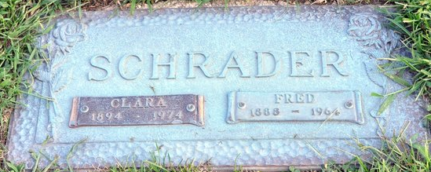
Photo by Deb Curry

Clara Schrader
in the U.S., Social Security Death Index, 1935-2014
Name Clara Schrader
Social Security Number xxx
Birth Date 8 Mar 1894
Issue year 1973
Issue State Arizona
Last Residence 85016, Phoenix, Maricopa, Arizona, USA
Death Date Dec 1974

