Ray A. Schott
April 3, 1919 – April 15, 1993

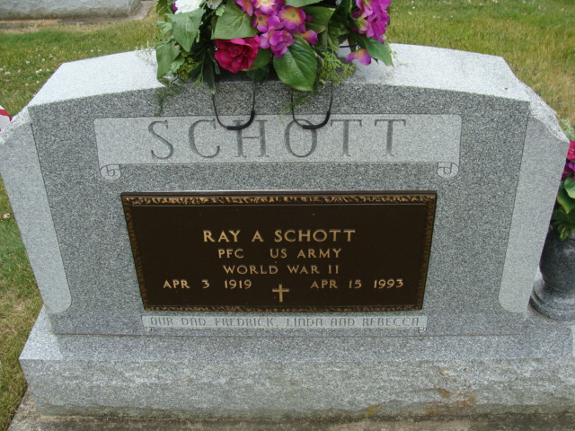
Photo by Alicia Kneuss

Ray A Schott
in the Indiana, U.S., Death Certificates, 1899-2017
Name Ray A Schott
Gender Male
Race White
Age 74
Marital Status Divorced
Birth Date 3 Apr 1919
Birth Place Chattanooga, Ohio
Death Date 15 Apr 1993
Death Place Fort Wayne, Allen, Indiana, USA
Death Registration Date 1993
Father Fred Schott
Mother Minnie Emerick
Informant Rebecca Smith; daughter; Fort Wayne, Indiana
Burial: April 17, 1993; Decatur Cemetery; Decatur, Indiana

