Robert Carl Schoenherr
April 27, 1925 – April 19, 2023

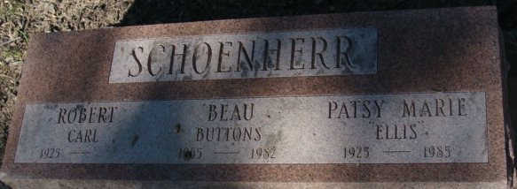
Photo of Alicia Kneuss

Robert C. Schoenherr, 97, of Decatur formerly of Fort Wayne, passed away Wednesday afternoon, April 19, 2023. He was born to the late Paul and Mildred (Disler) Schoenherr on April 27, 1925. Robert married Patsy Marie Ellis in 1946, who is now deceased. On August 5, 1987, he married Phyllis A. (Heimann) Feasel.
He attended Central High School and joined the U.S. Navy in 1943, during World War II. Bob went to Navy gunnery school and was gunner on the SS Charles H. Herty, a merchant ship, carrying bombs to England. He transferred to the fleet aboard the USS Randolph (CV-15). Bob earned 3 Battle Stars in the Pacific. He also served in the Korean Conflict, aboard the USS Essex (CV-9)
Bob worked for the Fort Wayne Fire Department, retiring after 29 years of service.
He is survived by his wife of 35 years, Phyllis Schoenherr of Decatur; a daughter, Dawn Carter of Texas; a daughter-in-law, Ginger Schoenherr of Ft. Wayne; a grandchild, Eric (Heather) Schoenherr; 3 step children, Brenda Myers, Steve (Vanessa) Feasel, Jim (Nancy) Feasel; 7 grandchildren; 15 great grandchildren.
Bob was preceded in death by his son, Jim Schoenherr; a sister, Pauline Colven; a brother, Don Scheonherr; a granddaughter, Jessica Autumn Schoenherr.
There will be a Private Graveside Service with Military Rites rendered by the American Legion Adams Post 43 Color Guard in the Decatur Cemetery.
Preferred memorials may be made to the VA Hospital or Honor Flight of Northeast Indiana.

Haggard & Sefton Funeral Home, Adams County, Indiana
April 20, 2023

