Patsy Marie (Ellis) Morgan-Schoenherr
October 1, 1925 – March 18, 1985

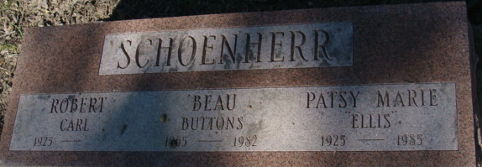
Photo by Alicia Kneuss

Indiana, Death Certificates, 1899-2011
Name: Patsy M Schoenherr
[Patsy M Ellis]
Gender: Female
Race: White
Age: 99
Marital status: Widowed
Birth Date: 1 Oct 1925
Birth Place: Mich
Death Date: 18 Mar 1985
Death Place: Ft Wayne, Allen, Indiana, USA
Father: Jim Ellis
Mother: Effie Drum
Spouse: Robert Schoenherr, informant
Cremation: 3-30-1985 Lindenwood

