Beau Buttons Schoenherr
1865 - 1982

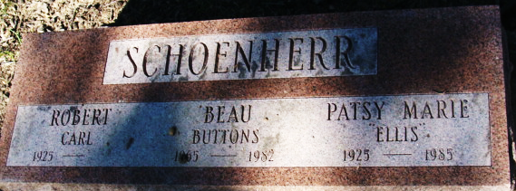
Photo by Alicia Kneuss

Beau Buttons Schoenherr from tree Gamble Family Tree
Birth 1965
Death 1982
Father Robert Carl Schoenherr (Born 1925)
Mother Patsy Marie Ellis (1925-1985)

