Sarah (Vollmar) Schnitz
October 19, 1876 – May 28, 1957

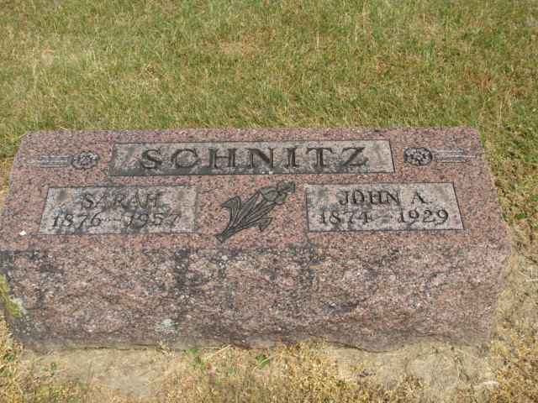
Photo by Alicia Kneuss

Sarah Schnitz
in the Indiana, U.S., Death Certificates, 1899-2017
Name Sarah Schnitz
[Sarah Vollman]
Gender Female
Race White
Age 80
Marital Status Widowed
Birth Date 19 Oct 1877
Birth Place Indiana
Death Date 28 May 1957
Death Place Decatur, Adams, Indiana, USA
Death Registration Date 1957
Father Peter Vollmar
Mother Wilhelmina Felton
Informant Mrs. Wilhelmina Beeth; daughter; Fort Wayne, Indiana
Burial: May 31, 1957; Decatur Cemetery; Decatur, Indiana

