Sarah M. (Fuhrman) Schnitz
September 4, 1864 – December 21, 1953

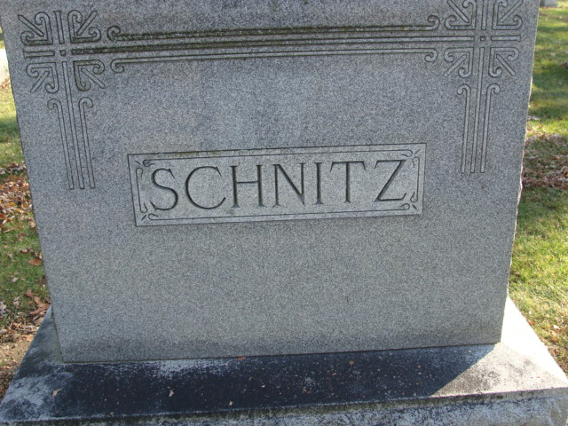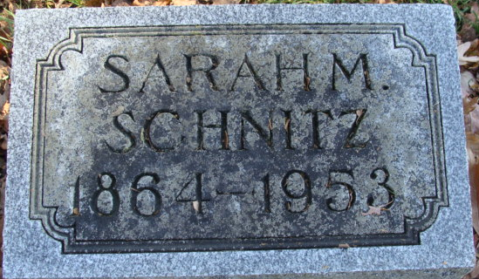
Photos by Alicia Kneuss

Sarah M Schnitz
in the Indiana, U.S., Death Certificates, 1899-2017
Name Sarah M Schnitz
[Sarah M Fuhrman]
Gender Female
Race White
Age 89
Marital Status Widow
Birth Date 4 Sep 1864
Birth Place Decatur, Indiana
Death Date 21 Dec 1953
Death Place New Carlisle, St Joseph, Indiana, USA
Death Registration Date 1953
Father Henry C Fuhrman
Mother Mary Beck
Informant: Can't read
Burial: December 24, 1953; Decatur Cemetery; Decatur, Indiana

