Robert J. Schnitz
March 28, 1921 – August 30, 2004

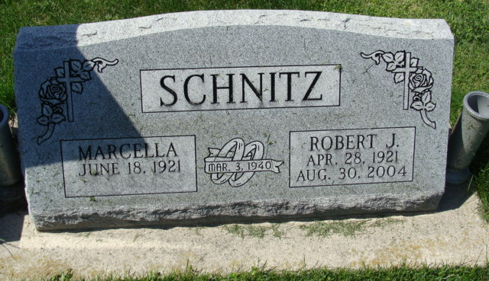
Photo by Alicia Kneuss

Bobby Schnitz Junior
in the Indiana, U.S., Birth Certificates, 1907-1944

Name (Bobby) Schnitz Junior
Gender Male
Birth Date 28 Apr 1921
Birth Place Decatur Ind, Adams, Indiana, USA
Father Meril Nelson Schnitz; age 20
Mother Florence Leora Snyder; age 19; 1st child
Certificate Number 17662
Roll number 40474_356368
Volume Range 31 - 36
**

Robert (Bobby) Junior Schnitz in Alvarez Family Tree

Spouse Alvina Marcella Tutewiler
Father Merrill Nelson Schnitz
Mother Florence Leora Snyder
Children Richard Allen
Birth 28 Apr 1921 Decatur, Adams, Indiana, USA
Death 30 Aug 2004 Leesburg, Lake, Florida, USA
Residence 1930 Decatur, Adams, Indiana, USA

