Richard K. Schnitz
November 21, 1922 – June 15, 2012

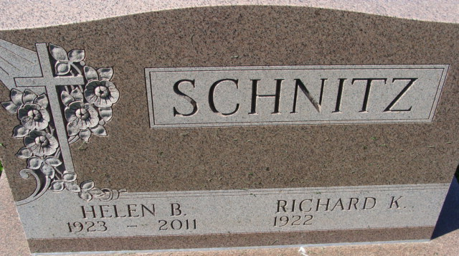
Photo by Alicia Kneuss

Richard K. Schnitz, 89 years old of Decatur, Indiana, passed away on Friday, June 15, 2012 in Woodcrest Nursing Center. He was born on Tuesday, November 21, 1922 in Decatur, Indiana the son of the late Merrill N. Schnitz and the late Florence L. (Snyder) Schnitz. He married Helen B. Brown on November 13, 1943 in Bluffton, Indiana and she passed away on September 18, 2011.
Richard was a member of the First Baptist Church in Decatur where he held various offices and was awarded Deacon Emeritus. He was also a member of the General Electric Quarter Century Club. He retired in 1983 from General Electric after forty-one years of service.
Surviving is his son, P. Daniel (Joyce) Schnitz of Monroe; son, T. David (Sheila) Schnitz of Decatur; daughter, Ruth E. Gallogly of Decatur; brother, Ralph A. Schnitz of Defiance, Ohio; seven grandchildren, and thirteen great-grandchildren.
Preceding Richard in death were a grandson, Jeffrey Daniel Schnitz and a brother, Robert J. Schnitz.
Funeral services will be held at 10:00 a.m. Tuesday, June 19, 2012 in the Zwick & Jahn Funeral Home with Pastor Whitney West officiating. Interment will follow in the Decatur Cemetery. Friends will be received from 2 to 4 and 5 to 8 p.m., Monday, June 18 in the Zwick & Jahn Funeral Home, Decatur.
Preferred memorials are to First Baptist Church.

Zwick & Jahn Funeral Home, Adams County, Indiana
June 15, 2012

