Merrill N. Schnitz
December 29, 1900 – September 29, 1948

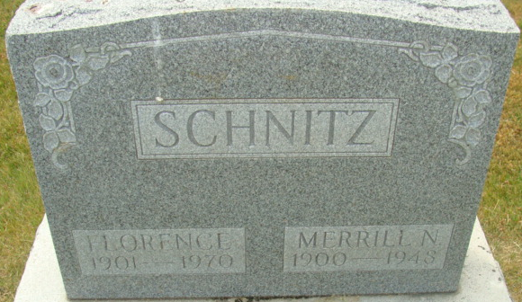
Photo by Alicia Kneuss

Indiana, U.S., Death Certificates, 1899-2017

Name Merle N Schnitz
Gender Male
Race White
Age 47y 8m 30d
Marital Status Married
Birth Date 29 Dec 1900
Birth Place Huntington Indiana
Death Date 29 Sep 1948
Death Place Decatur, Adams, Indiana, USA
Death Registration Date 1948
Father John Schnitz
Mother Sarah Vallmar
Spouse Florence Snyder Schnitz, informant
Burial Decatur Cemetery 10-1-1948

