Louisa A. (Fuhrman) Schnitz
March 10, 1868 – November 6, 1956

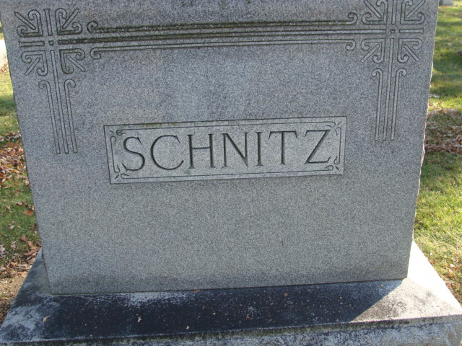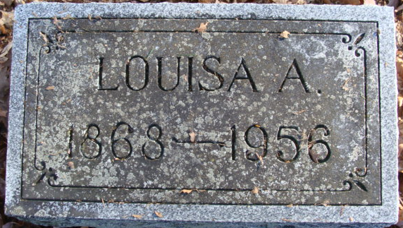
Photos by Alicia Kneuss

Mrs. Louisa Schnitz Dies Last Evening
Funeral Services Friday Afternoon
Mrs. Louisa A. Schnitz, 88, a resident of Decatur most of her life, died at 7.30 o’clock Tuesday evening at the Haven Hubbard Memorial Home at New Carlisle, following a year’s illness. She had resided at the home since 1945.
She was born in Adams County March 10, 1868, a daughter of Henry C. and Mary Beck-Fuhrman, and was married to Charles H. Schnitz, who preceded her in death.
Mrs. Schnitz was an active worker in the Bethany Evangelical United Brethren Church while residing in Decatur.
Only near surviving relative is a sister, Mrs. Laura Sprunger of Livingston, Mont.
Funeral services will be conducted at 1 p.m. Friday at the Zwick Funeral Home, the Rev. Benjamin G. Thomas officiating. Burial will be in the Decatur Cemetery. Friends may call at the funeral home after 7 o’clock this evening until time of the services.
Decatur Daily Democrat, Adams County, Indiana
Wednesday, November 7, 1956

**
Lueasa /Louisa (Eliz) (Lou) A. Fuhrman Schnitz in Sprunger Family Tree
Spouse Charles H. m.Fuhrman Schnitz
Father Henry Christian (Charles) Fuhrman
Mother Anna Marie (Mary) (May) Beck Fuhrman
Birth 10 Mar 1868 Adams, Indiana, USA
Death 6 Nov 1956 New Carlisle, St Joseph, Indiana, USA
Residence 1880 Adams, Indiana, USA

