John Adams Schnitz
March 31, 1874 – August 21, 1929

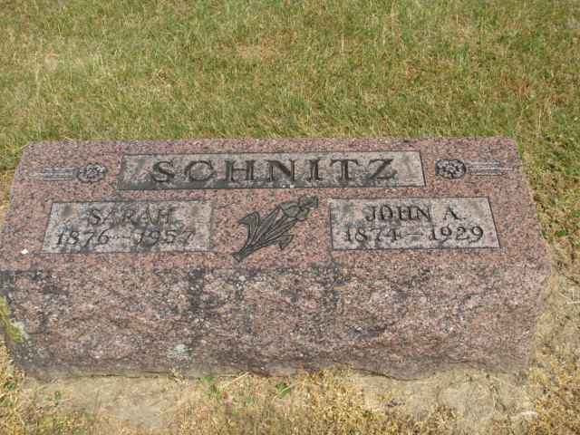
Photo by Alicia Kneuss

John Adams Schnitz in Alvarez Family Tree
Spouse Sarah Vollmar
Father John Gottleib Schnitz
Mother Christina Schnitz
Children Merrill Nelson
Birth 31 Mar 1873 Andrews, Huntington, Indiana, USA
Death 21 Aug 1929 Decatur, Adams, Indiana, USA
Residence 1880 Huntington, Indiana, USA

