Helen B. (Brown) Schnitz
July 29, 1923 – September 18, 2011

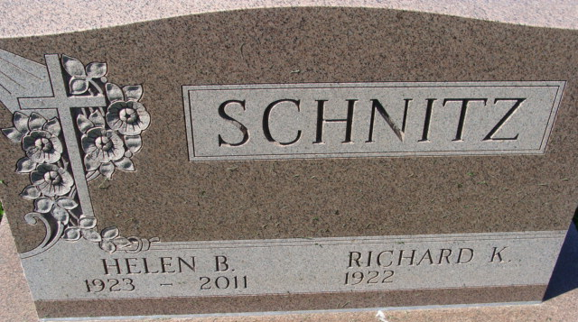
Photos by Alicia Kneuss

Helen B. Schnitz, 88 years old of Decatur, Indiana, passed away at 12:00 Noon on Sunday, September 18, 2011 in the Woodcrest Nursing Center located in Decatur. Helen was born on Sunday, July 29, 1923 in Huntington County, Indiana, the daughter of the late Mahlon D. Brown and the late Mildred G. (Beal) Brown. She married Richard K. Schnitz on November 13, 1943 in Bluffton, Indiana and he survives.
Helen was a member of the First Baptist Church in Decatur.
Helen was the owner of Schnitz Accounting Service from 1945 until her retirement in 2001.
Surviving are her husband, Richard K. Schnitz of Decatur, Indiana; son, P. Daniel (Joyce) Schnitz of Monroe, Indiana; son, T. David (Sheila) Schnitz of Decatur, Indiana; daughter, Ruth E. Gallogly of Decatur, Indiana; brother, Marvin L. Brown of Valparaiso, Indiana; sister, Doris Alexander of Franklin, Indiana; brother, Larry W. (Shirley) Brown of Nineva, Indiana; brother, Carl E. Brown of Largo, Florida; sister, Linda K. (Jerry) Higgins of Plano, Texas; sister, Judith (Philip) Hoopingarner of New Haven, Indiana; seven grandchildren, twelve great-grandchildren.
Preceding Helen in death were 2 brothers, Harold and Robert Brown; 2 sisters, Maxine L. Moser and Bertha Jean Malson; and 1 grandson, Jeffrey Daniel Schnitz.
Funeral services will be held at 11:00 a.m. Friday, September 23, 2011 in the Zwick & Jahn Funeral Home with Pastor Whitney West officiating. Interment will follow in the Decatur Cemetery. Friends will be received from 12-1 p.m. Thursday, September 22, 2011 at the Woodcrest Chapel and from 3-5 and 6-8 p.m. Thursday in the Zwick and Jahn Funeral Home, Decatur, Indiana and from 9:00 a.m. until service time at the funeral home on Friday.
Preferred memorials are to First Baptist Church or A.C.C.F. - Heart Fund.

Zwick & Jahn Funeral Home, Adams County, Indiana
September 19, 2011

