Florence L. (Snyder) Schnitz
July 28, 1901 – September 2, 1970

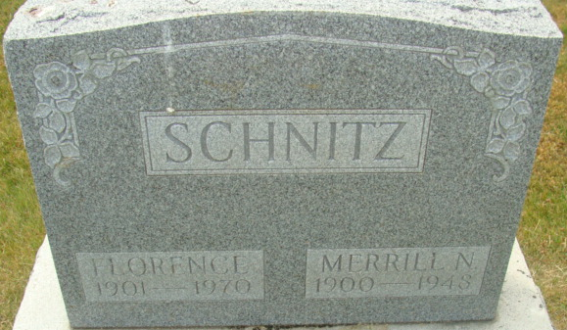
Photo of Alicia Kneuss

Florence Schnitz Dies this Morning

Mrs. Florence L. Schnitz, 69, of St. Petersburg, Fla., a resident of Decatur most of her life, died at 4:30 a.m. today at the Bay Front Medical Center in St. Petersburg. She had been ill since May.
Mrs. Schnitz was formerly employed at the General Electric Co., and the Adams County Memorial Hospital.
She was born in Adams County on July 28, 1901, a daughter of Frank and Cora Higgins-Snyder, and was married to Merrill N. Schnitz Nov. 18, 1919. Her husband preceded her in death Sept. 28, 1948.
Mrs. Schnitz was a member of the Albright United Methodist Memorial Church at St. Petersburg.
Surviving are three sons, Robert J. Schnitz of Cleveland, O., Richard K. Schnitz of Decatur, and Ralph A. Schnitz of Defiance, O.; her mother, Mrs. Cora Snyder of St. Petersburg; two sisters, Mrs. Ralph (Nola) Loose of St. Petersburg, and Mrs. Norbert (Lillian) Hattendorf of Tampa, Indiana, 10 grandchildren and six great-grandchildren. Two brothers and one great-grandchild are deceased.
The body will be returned to Zwick Funeral Home. Funeral arrangements have not been completed.

Decatur Daily Democrat, Adams County, Indiana
Wednesday, September 2, 1970

