Emmanuel M Schnitz
July 12, 1860 – March 4, 1919

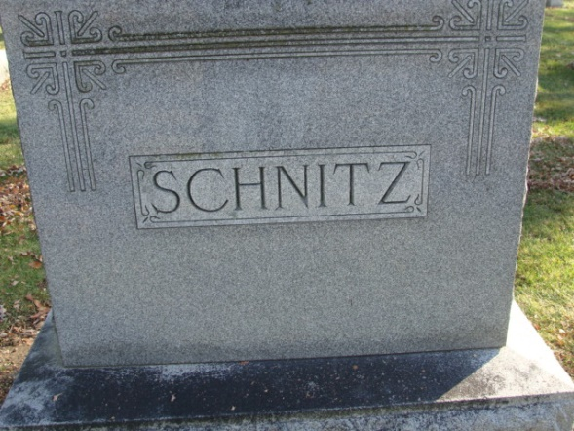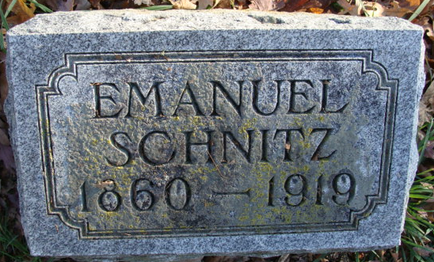
Photos by Alicia Kneuss

DEATH OF EMANUEL SCHNITZ

DECATUR, Ind. March 5 – Emanuel Schnitz, aged 58, well known mechanic, died last night at 6:40 o'clock at the home on North Second Street, following a stroke of apoplexy received last Saturday morning. Death came easily and peacefully as he slept. He had been in failing health from heart trouble since last fall. A coincidence is that his death occurred two years after, to the very day, that of his sister, Mrs. Mary Hockensmith, of Roanoke, who also died of apoplexy.
His is survived by the wife, who was Miss Sarah Fuhrman and one daughter, Zelda, wife of Clinton Mart of Root Township. He had one brother, John, of this city. Four brothers are deceased, none of them living to be sixty years of age.

Fort Wayne News & Sentinel, Allen County, Indiana
March 5, 1919

**
Indiana, U.S., Death Certificates, 1899-2017
Name Emanuel Schnitz
Gender Male
Race White
Age 58
Marital Status Married
Birth Date 12 Jul 1860
Birth Place Indiana
Death Date 4 Mar 1919
Death Place Decatur, Adams, Indiana, USA
Death Registration Date 1919
Father John Schnitz
Mother Christiana Rhyneholt
Spouse Sadie
Informant: Mrs. Sadie Schnitz; Decatur, Indiana
Burial: March 7, 1919; Decatur Cemetery

