Charles H. Schnitz
October 8, 1868 – August 14, 1921

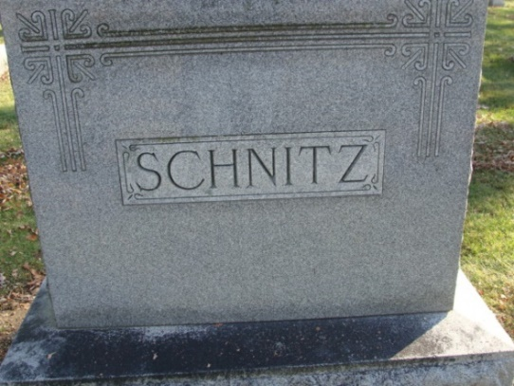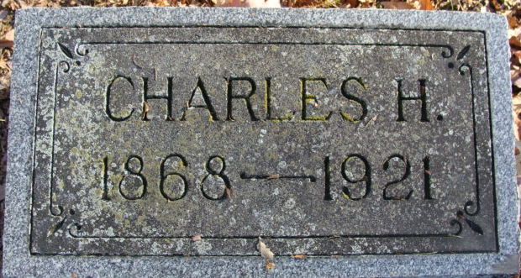
Photos by Alicia Kneuss

Charles H. Schuitz
in the Indiana, U.S., Death Certificates, 1899-2017
Name Charles H. Schnitz
Gender Male
Race White
Age 52
Marital Status Married
Birth Date 8 Oct 1868
Birth Place Ohio
Death Date 14 Aug 1921
Death Place Decatur, Adams, Indiana, USA
Death Registration Date 1921
Father Henry Schnitz
Mother Mary Bought
Spouse Louise Fuhrman
Informant: Mrs. Chas. Schnitz; Decatur, Indiana
Burial: August 16, 1921; Decatur Cemetery

