Vilora (Miller) Schnepp
January 4, 1896 – September 25, 1990

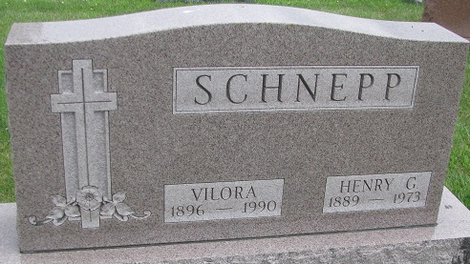
Photo by PLS

Vilora Schnepp
in the Indiana, U.S., Death Certificates, 1899-2017
Name Vilora Schnepp
[Vilora Miller]
Gender Female
Race White
Age 94
Marital Status Widowed
Birth Date 4 Jan 1896
Birth Place Van Wert, Ohio
Death Date 25 Sep 1990
Death Place Angola, Steuben, Indiana, USA
Death Registration Date 1990
Father Willard Miller
Mother Cora B Hitchcock
Informant: Berneice Henning; daughter; Angola, Indiana
Burial: September 27, 1990; Decatur Cemetery; Decatur, Indiana

