Verona Mae (Snyder) Schnepp
April 5, 1905 – March 31, 1956

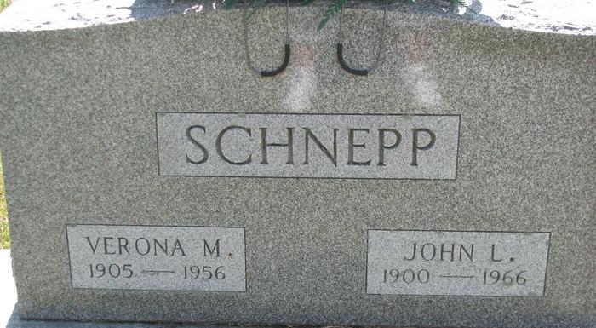
Photo by PLS

PETERSON WOMAN TAKEN BY DEATH

Mrs. Verona Schnepp, 50, of near Peterson, died at 2:40 p.m. Saturday, in the Clinic Hospital, Bluffton, where she had been a patient two weeks. She had been in ill health 10 months.
Survivors besides the husband are a daughter, Mrs. Waunetta Berry, Bluffton; two grandchildren; one brother, J. Earl Snyder, Jones, Michigan; and two sisters, Mrs. Melvin Mahler, Millersburg and Mrs. Gerry Hagerty, Mishawaka.
Friends may call at the Zwick Funeral Home in Decatur where services will be held at 2:00 p.m. Tuesday. Burial will be in the Decatur Cemetery.

The Berne Witness; Adams County, Indiana
Monday, April 2, 1956

**
Mrs. John Schnepp Is Taken By Death
Funeral Services Tuesday Afternoon

Mrs. Verona Schnepp, 50, who resided one-half mile south of Peterson, died at 2:40 o’clock Saturday afternoon at the Clinic Hospital in Bluffton. She had been ill for 10 months and hospitalized for two weeks.
She was born in LaGrange County April 5, 1905, a daughter of John and Sylvia Cunningham - Snyder, and was married to John Schnepp March 7, 1925. The family had resided near Peterson for the past eight years.
Surviving.in addition to her husband are a daughter, Mrs. Waunetta Beery of Bluffton; two grandchildren; one brother, J. Earl Snyder of Jones, Mich., and two sisters, Mrs. Melvin Mahlin of Millersburg and Mrs. Gerry Hagerty of Mishawaka. One brother preceded her in death.
Funeral services will be conducted at 2 p.m. Tuesday at the Zwick Funeral Home, the Rev. Charles L. Collier officiating. Burial will be in the Decatur Cemetery. Friends may call at the funeral home until time of the services.

Decatur Daily Democrat, Adams County, Indiana
Monday, April 2, 1956
**

Indiana, U.S., Marriages, 1810-2001

Name Verona Mae Snyder
Gender Female
Race White
Age 20
Event Type Marriage Registration (Marriage)
Birth Date 5 Apr 1905
Birth Place LaGrange, Indiana
Marriage Date 7 Mar 1925
Marriage Place Indiana, United States
Residence Place Elkhart, Indiana
Father John Snyder
Mother Sylvia Cunningham
Spouse John Lawrence Schnepp

