Vall C. Schnepp
June 10, 1884 – August 5, 1956

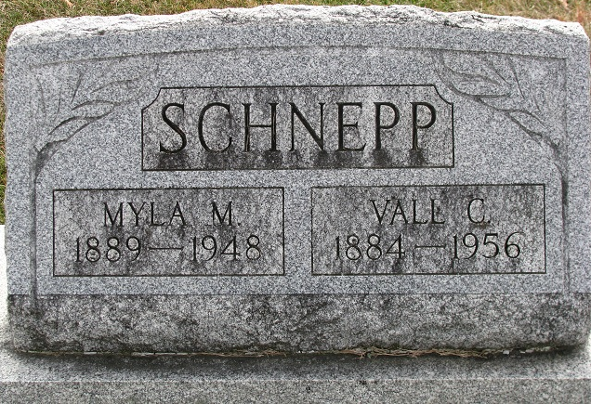
Photo by PLS

FORMER HIGHWAY EMPLOYE DIES
Funeral Today for Vall Schnepp, 72, Union Township

Vall Schnepp, 72, of Union Township, former employe of the Adams County Highway Department, died at 9:20 o'clock Sunday night at the Davis Nursing Home in Bluffton. He had been ill since suffering a cerebral hemorrhage two years ago.
Mr. Schnepp worked for the highway department until 1953. He was a member of the Calvary Evangelical United Brethren Church. A resident of Union Township most of his life, he lived with a brother, Charles, for three years, and had been a patient at the nursing home for 18 months.
He was born in Adams County June 10, 1884, a son of Frank and Hannah Barrone Schnepp. His wife, the former Myla Miller, died August 18, 1948.
Only near survivors are two brothers, Henry Schnepp of Fort Wayne and Charles Schnepp of Decatur, route 4.
Funeral services were conducted at 2 p.m. today at the Zwick Funeral Home, the Rev. Burton Lange officiating. Burial was in the Decatur Cemetery.

The Berne Witness; Adams County, Indiana
Wednesday, August 8, 1956

