Terry W. Schnepp
April 7, 1941 – May 24, 2023

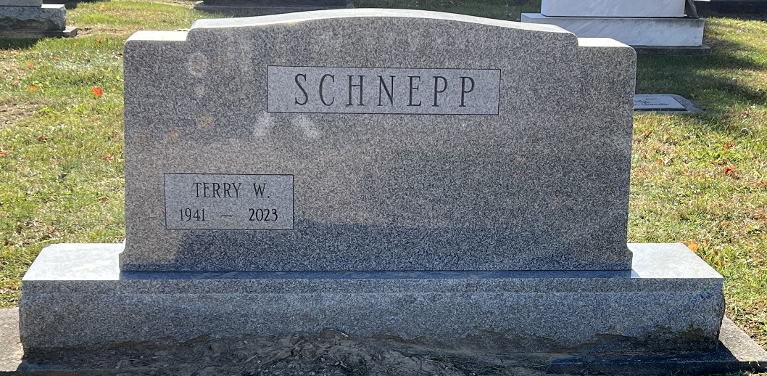
Photo of Deb Curry
Terry W. Schnepp, 82, of Decatur, Indiana, passed away Wednesday, May 24, 2023, at Woodcrest Assisted Living. Born April 7, 1941 in Adams County, Terry was the son of the late Dwight A. and Belva T. (Huser) Schnepp.
He attended the Decatur Church of God. He was an avid Harley rider in his early years and loved going to California. He enjoyed tractor pulls, attending car shows, wrestling, and LOVED HIS FORD TRUCK! Terry worked for many years at Decatur Industries and at Custom Car Care as their errand guy.
Terry is survived by his brother, Roger (Nancy) Schnepp of The Villages, FL; 2 sisters, Gretchen (Berdell) Lehman and Gyneth (Leslie) Augsburger both of Berne, IN; 6 nieces and nephews, Kevin (Gail) Lehman, Douglas (Shelly) Lehman, Gerri (Douglas) Fisher, Kim (Mark) Flueckiger, Beau Schnepp and Ashley Schnepp; and 7 great nieces and nephews.
Visitation will be from 4:00 – 8:00 p.m. Friday, June 2, 2023, at Haggard-Hirschy & Zelt Funeral Home. A Funeral Service will be held on Saturday, June 3, 2023, at Haggard-Hirschy & Zelt Funeral Home, with visitation 1 hour prior from 9:30 – 10:30 a.m. Pastor Brent Doster will be officiating and burial will immediately follow in the Decatur Cemetery.
Preferred memorials may be made to the Decatur Church of God.

Haggard & Sefton Funeral Home, Adams County, Indiana
May 24, 2023

