Susan J. (Bowman) Schnepp
October 10, 1934 -

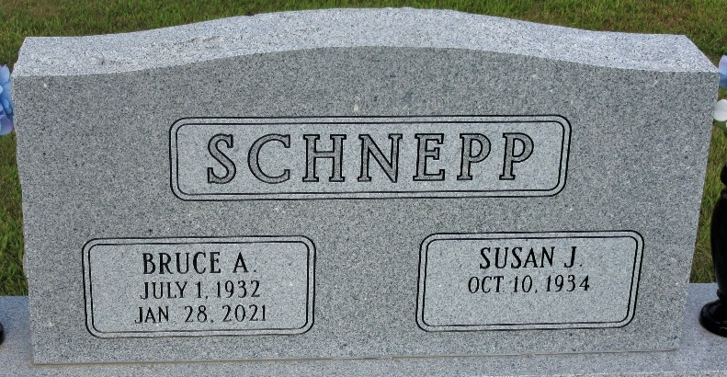
Photo by PLS

Susan Jane Bowman
in the Indiana, U.S., Birth Certificates, 1907-1944
Name Susan Jane Bowman
Gender Female
Birth Date 10 Oct 1934
Birth Place Decatur, Adams, Indiana, USA
Father Laverne Bowman; age 30
Mother Isabel Peterson; age 23; 2nd child, both living
Certificate Number 39071
Roll number 40474_357188
Volume Range 76 - 80

