Ralph L. Schnepp
May 16, 1893 – July 25, 1971

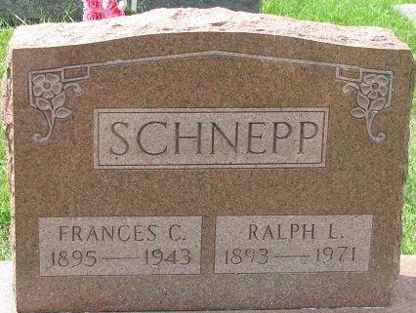
Photo of PLS

Ralph Schnepp Dies on Sunday

Ralph L .Schnepp, 78, of 908 North Third Street, died at 4:15 a.m. Sunday at the Lakeview Nursing Home, where he had been a resident for the past four weeks. He had been in failing health for two and one-half years.
Mr. Schnepp, a retired farmer and retired research department employee of Central Soya Co., had been active in harness racing for the past 12 years.
He was born in Adams County May 16, 1893, a son of Abe and Emma McGill-Schnepp, and was married to Frances Zerkel April 19, 1917. His wife preceded him in death Sept 7, 1943.
He was a member of the Union Chapel United Methodist Church and an active member of the U.S. Trotting Association.
Surviving are one daughter, Mrs. Royal (Esther) Friend of Decatur; one son, Hubert G. Schnepp of Hamilton; one sister, Mrs. Russel (Naomi) Kryder of Fort Wayne; one brother, Dwight Schnepp of Decatur Route 1; three grandchildren and three great-grandchildren. One sister and one brother are deceased.
Funeral services will be conducted at 1:30 p.m. Tuesday at the Zwick Funeral Home, with Rev. Kenneth Swan and Rev. L.T. Norris officiating. Burial will be in the Decatur Cemetery. Friends may call at the funeral home after 2 p.m. today until time of services.

Decatur Daily Democrat, Adams County, Indiana
Monday, July 26, 1971

