Opal L. (Wright) Schnepp
February 12, 1909 – December 16, 1992

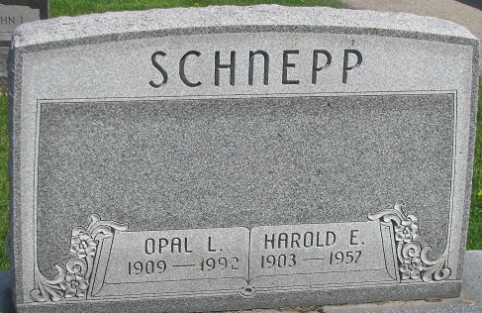
Photo by PLS

Opal L Schnepp
in the Indiana, U.S., Death Certificates, 1899-2017
Name Opal L Schnepp
[Opal L Wright]
Gender Female
Race White
Age 83
Marital Status Widowed
Birth Date 12 Feb 1909
Birth Place Allen Michigan
Death Date 16 Dec 1992
Death Place Fort Wayne, Allen, Indiana, USA
Death Registration Date 1992
Father John Wirter Wright
Mother Minerva Armstrong
Informant: Phyllis Bryant; daughter; Decatur, Indiana
Burial: December 19, 1992; Decatur Cemetery; Decatur, Indiana

