Oliver Schnepp
October 9, 1891 – December 8, 1974

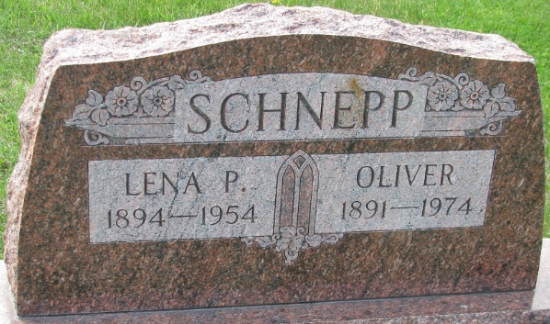
Photo by PLS

Oliver Schnepp, 83, a resident of 124 E. Grant St. in Decatur and a World War I veteran died suddenly at 5:50 p.m. Sunday at the Adams County Memorial Hospital.
Born October 9, 1891 in Union township to Solomon and Letitia Walters Schnepp he was a body and fender man with the Al Schmitt Dodge and Schwarts Ford Co., agencies for 35 years before retiring. Mr. Schnepp was a member of the Union Chapel United Methodist Church.
He was married on April 23, 1959, to Ruth F. Moser, who survives. Also surviving are one daughter, Mrs. Glen (Marcia) Neukom of Garrett; two sons, Lewis L. Schnepp of Fort Wayne and Kenneth M. Schnepp of Lansing, Mich; a stepson, Glenn D. Moser of Geneva; a stepdaughter, Mrs. Robert (Harriett) Williamson of Warsaw; one brother, Kenneth F. Schnepp of Fort Wayne; 10 grandchildren and five great-grandchildren; eight step-grandchildren and eight step-great-grandchildren. One son, Bell Schnepp, and four brothers preceded him in death.
Funeral services will be held at 2 p.m. Wednesday at Winteregg-Linn & Haggard Funeral Home, the Rev. Kenneth Swan in charge and burial will be in the Decatur Cemetery. Friends may call at the funeral home after 7 p.m. Monday.

Decatur Daily Democrat, Adams County, Indiana
Monday, December 9, 1974

