Myla May (Miller) Schnepp
October 2, 1889 – August 4, 1948

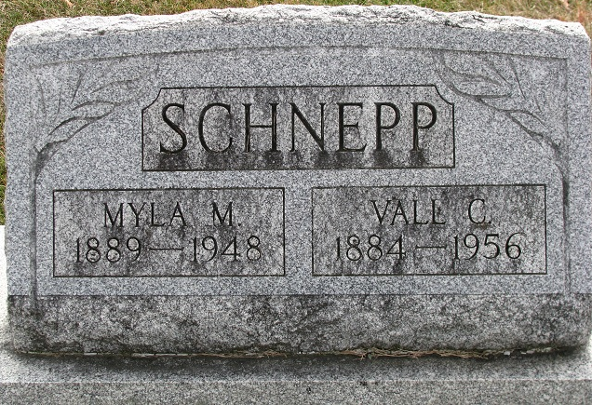
Photo by PLS

Mrs Myla May Schnepp
in the Indiana, U.S., Death Certificates, 1899-2017
Name Mrs Myla May Schnepp
[Mrs Myla May Miller]
Gender Female
Race White
Age 58
Marital Status Married
Birth Date 2 Oct 1889
Birth Place Adams Co Indiana
Death Date 4 Aug 1948
Death Place Decatur, Adams, Indiana, USA
Death Registration Date 1948
Father Charles Miller
Mother Tressa Springer
Spouse Vall Schnepp; age 60
Informant: Vall Schnepp; Decatur, Indiana
Burial: August 7, 1948; Decatur Cemetery; Decatur, Indiana

