Lucy H. (Bowsher) Schnepp
May 16, 1903 – December 7, 1996

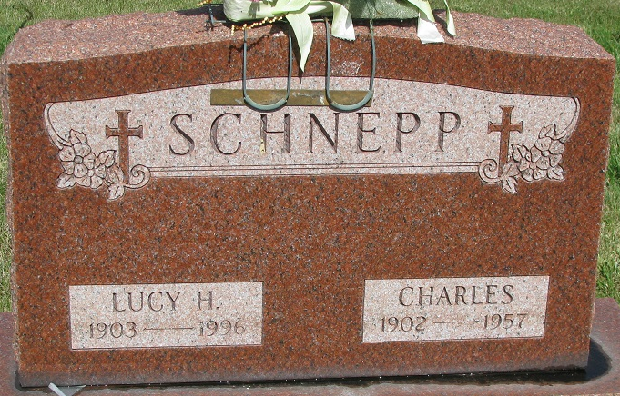
Photo by PLS

Lucy H Schnepp
in the Indiana, U.S., Death Certificates, 1899-2017
Name Lucy H Schnepp
[Lucy H Bowsher]
Gender Female
Race White
Age 93
Marital Status Widowed
Birth Date 16 May 1903
Birth Place Ohio
Death Date 7 Dec 1996
Death Place Decatur, Adams, Indiana, USA
Death Registration Date 1996
Father Albert Bowsher
Mother Emma Sunderland
Informant: Bruce A. Schnepp; son; Decatur, Indiana
Burial: December 11, 1996; Decatur Cemetery; Decatur, Indiana

