Lois Jean (Mitchel) Schnepp
May 16, 1927 – August 24, 1997

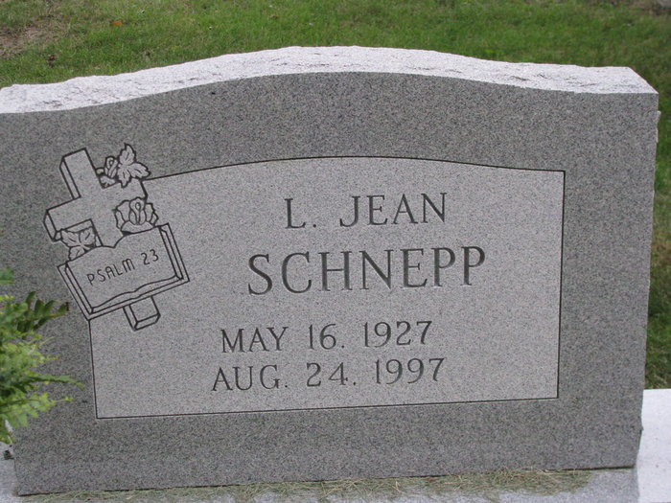
Photo by PLS

Jean Schnepp, 70, of Clearwater, Fla., died Sunday at Lutheran Hospital, Fort Wayne. The Adams County native retired in 1989 from Superior Manufacturing Co. in Clearwater. She was formerly employed at Central Soya in Decatur.
Surviving are sisters, Joan Morningstar of Decatur and Shirley Troutner of Monroeville; a brother, Lester Mitchel of Roanoke; and three grandsons.
Services are 1 p.m. Wednesday at Zwick-Sefton & Jahn Funeral Home, Decatur. Calling is from 2 to 5 and 7 to 9 p.m. today. Burial will be in Decatur Cemetery.
Memorials are to First Baptist Church, Decatur.

**
Indiana, U.S., Death Certificates, 1899-2017
Name L. Jean Schnepp
[L. Jean Mitchel]
Gender Female
Race White
Age 70
Marital Status Divorced
Birth Date 16 May 1927
Birth Place Adams County, Indiana
Death Date 24 Aug 1997
Death Place Fort Wayne, Allen, Indiana, USA
Death Registration Date 1997
Father Clarence W. Mitchel
Mother Ora B. Durbin
Informant: Carla Roahrig; daughter; Clearwater, Florida
Burial: August 27, 1997; Decatur Cemetery; Decatur, Indiana

**
Family Search Record - Indiana Marriages
groom: Lawrence N Fuelling
groom's race: White
groom's date of birth: 14 Feb 1922; groom's place of birth: , Adams, Indiana groom's residence: Decatur, , Indiana; groom's number of marriage: 1st groom's father: Otto C Fuelling; groom's mother: Elsie Schultz
bride: Lois Jean Mitchel
bride's race: White
bride's date of birth: 16 May 1927; bride's place of birth: , Adams, Indiana bride's residence: Decatur, , Indiana; bride's number of marriage: 1st; bride's father: Clarence Mitchel; bride's mother: Ora Durbin
date of license: 28 Jun 1947; date of marriage: 29 Jun 1947
place of marriage: Adams, Indiana
digital folder number: 4186034; number of images: 1

**
Indiana, U.S., Marriages, 1810-2001
Name Jean Fuelling
Gender Female
Event Type Marriage Registration (Marriage)
Marriage Date 11 Jun 1955
Marriage Place Indiana, United States
Spouse Hubert G Schnepp
Page 23
FHL Film Number 002240287

