Leonard Wilson Schnepp
February 27, 1875 – October 2, 1938

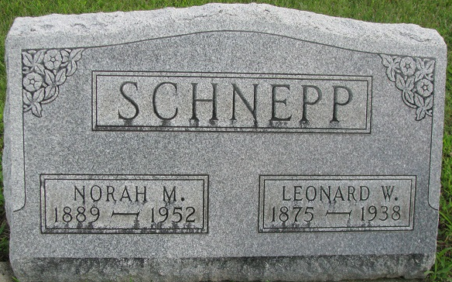
Photo of PLS

Van Wert Grade Crossing Scene of Fatality; Bodies Carried 300 Feet

Two persons were killed and two others were injured seriously in Lima district traffic mishaps Sunday as Ohio's week-end toll counted six fatalities.
The dead are Leonard Schnepp, 63, of Union Township, near Van Wert and Clarence Miller, 44, of one-half mile west of the Ohio-Indiana State Line, killed instantly about 2 p.m. Sunday when their automobile was struck by an eastbound Pennsylvania passenger train at a grade crossing four miles west of Van Wert.
According to Sheriff R. B. Stevens, Schnepp, who had resided for four years just north of the fatal crossing, and Miller, who with his family were visiting at the Schnepp home, had driven from the driveway and started south of Van Wert to attend a baseball game.
BODIES CARRIED 300 FEET ON TRACK
Miller drove onto the tracks directly in front of the fast train, Stevens reported. The bodies of the victims were carried more than 300 feet and dropped between the main tracks.

Miller's body was taken to Decatur, Ind. Schnepp's body was removed to the Gamble and Alspach chapel, Van Wert. Funeral arrangements are incomplete.
(Article continues about another accident)

Lima News, Allen County, Ohio
Monday, October 3, 1938

**
Funerals of Car Victims On Tuesday
Three Killed In and Near Van Wert, O.; Former Berne Man Crushed

VAN WERT, O., Oct. 3. - Three persons were killed in accidents in this city and vicinity over the weekend, Leonard Schnepp, 63, of Union Township, and Clarence Miller, 44, of near Decatur, Ind., were instantly killed Sunday afternoon when the car in which they were riding was struck by eastbound Pennsylvania Railroad passenger train at Richey, four miles west of this city. Richard Hammond, 24, was fatally hurt Saturday afternoon when an emery wheel with which he was working at the General Implements Foundry here broke and struck him in the abdomen. Funeral services for Hammond were held today at the Second M. E. Church; Burial in Woodland Cemetery.
Survivors include the parents, Mr. and Mrs. Clifford Hammond, of this city; two brothers, Eugene and Joe Hammond, and one sister, Mrs. Paul Ingledew, all of Van Wert. He was rushed to the county hospital here, where he died shortly afterward of a ruptured liver.
Funeral Set Tentatively
Funeral services for Schnepp have been set tentatively for Tuesday at 3 p.m., with burial at Decatur. Miller’s body was taken to Decatur for last rites and burial.
Schnepp and Miller, the latter Schnepp’s nephew, were on their way to a baseball game in Van Wert. They had just left Schnepp’s home. Miller was driving. The car was carried nearly a mile and a half, while the two bodies were found nearly 300 feet from the crossing.
Schnepp is survived by his widow, a son, Gerald Schnepp, and a brother, Abe Schnepp, of Monroe. Miller is survived by the widow, two sons, Orland, of near Decatur, and Harlow, at home; two daughters, Arvella and Rosella, both at home; a brother, Curtis Miller, and a sister, Mrs. Val Schnepp, both of near Decatur.

Adams County, Indiana Historical Museum
March 1938 – January 1939 Scrapbook, image 38-39, 44

**
Name: Leonard Wilson Schnepp
Event Type: Death
Event Date: 02 Oct 1938
Event Place: Pleasant Township, Van Wert, Ohio, United States
Event Place (Original): Pleasant Twp., Van Wert, Ohio
Address: RR # 4
Residence Place: Van Wert, O.
Gender: Male
Age: 63y 7m 5d
Marital Status: Married
Race: W
Race (Original): W
Occupation: farmer
Birth Date: 27 Feb 1875
Birthplace: Ind.
Burial Date: 04 Oct 1938
Cemetery: Decatur
Father's Name: Henry Schnepp
Father's Birthplace: Penna.
Mother's Name: Hannah Manley
Mother's Birthplace: Penna.
Spouse's Name: Norah
Informant: Mrs. Norah Schnepp; Van Wert, Ohio
Burial: October 4, 1938; Decatur Cemetery
Reference ID: item 3 cn 133
GS Film Number: 1952879
Digital Folder Number: 004254287
Digital Folder Number: 004254287
Image Number: 290
Indexing Project (Batch) Number: B01669-9
Record Number: 14
Citing this Record: "Ohio, County Death Records, 1840-2001," database with images, FamilySearch (https://familysearch.org/ark:/61903/1:1:F6CF-T9B : 10 March 2018), Leonard Wilson Schnepp, 02 Oct 1938; citing Death, Pleasant Township, Van Wert, Ohio, United States; County courthouses, Ohio; FHL microfilm 1,952,879.

