Lena Pearl (Bridgewater) Schnepp
December 11, 1894 – October 11, 1954

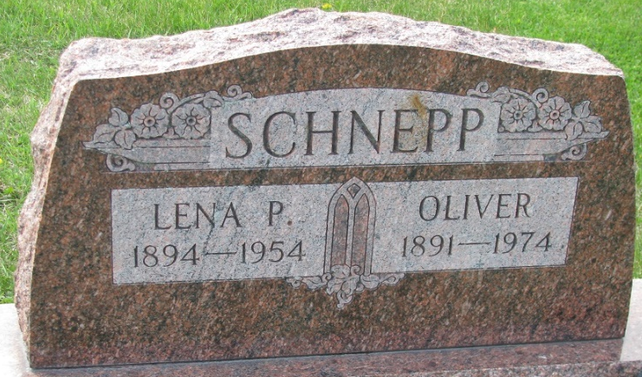
Photo by PLS

Lena Schnepp
in the Indiana, Death Certificates, 1899-2011
Name: Lena Schnepp
[Lena Baidewater]
Gender: Female
Race: White
Age: 53
Marital status: Widowed
Birth Date: 11 Dec 1895
Birth Place: Indiana
Death Date: 11 Oct 1954
Death Place: Terre Haute, Vigo, Indiana, USA
Father: Isaac Bridgewater
Mother: Mary Easter
Informant: Kenneth Schnepp; Ft. Wayne, Ind.
Burial: Oct. 14, 1954; Decatur Cem., Decatur, Ind.

