Kenneth M. Schnepp
June 16, 1923 – December 17, 1985

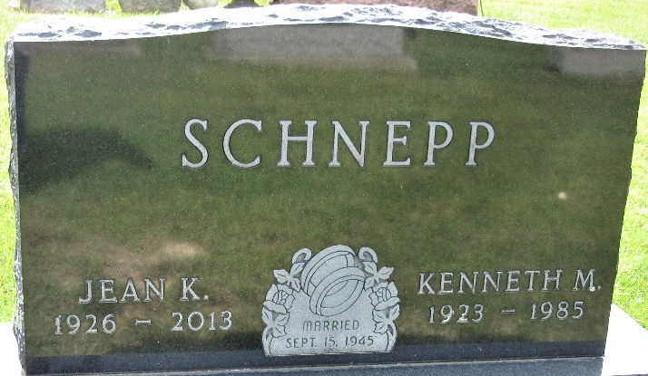
Photo by PLS

CALLING TODAY FOR KENNETH SCHNEPP
Kenneth Schnepp, 62, Roanoke, died suddenly Tuesday morning. He is the brother of Mrs. Glenn (Marsha) Neukom, 909 South Franklin Street.
Friends may call from 2 to 5 and 7 to 9 p.m. today at the Schaffer Memorial Chapel in Roanoke, where services will be held at 2 p.m. Friday. Burial will be in the Decatur Cemetery.
Mr. Schnepp was born June 16, 1923 to Oliver and Lena (Bridgewater) Schnepp. He recently retired from Renner's Express in Lansing, Mich.
Survivors besides the sister in Garrett include his wife, Jean; three sons, Kenneth Jr., Lansing; David, Roanoke; and Greg, stationed at Kelly Air Force Base, Tex; one daughter, Tonya, a student at Michigan State University, Lansing; one brother, Lewis Schnepp, Fort Wayne and three grandchildren.

Garrett Clipper, DeKalb County, Indiana
Thursday, December 19, 1985

