Keith B. Schnepp
June 9, 1930 – September 13, 1992

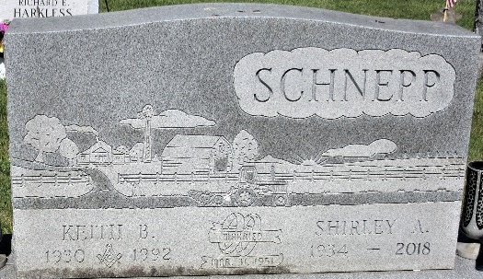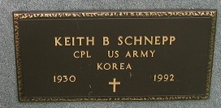
Photo by PLS

Keith B Schnepp
in the Michigan, U.S., Death Index, 1971-1996
Name Keith B Schnepp
Birth Date 9 Jun 1930
Death Date 13 Sep 1992
Gender Male
Residence Grand Blanc, Genesee, Michigan
Place of Death Flint, Genesee, Michigan

**
U.S., Social Security Applications and Claims Index, 1936-2007
Name Keith Bernard Schnepp
[Keith B Schnepp]
Gender Male
Race White
Birth Date 9 Jun 1930
Birth Place Decatur Adam, Indiana
Death Date 13 Sep 1992
Father Charles Schnepp
Mother Lucy H Bowsher
SSN xxx
Death Certificate Number 721 HILL F/H
Notes 12 May 1983: Name listed as KEITH BERNARD SCHNEPP; 18 Sep 1992: Name listed as KEITH B SCHNEPP

