John L. Schnepp
April 26, 1900 – November 20, 1966

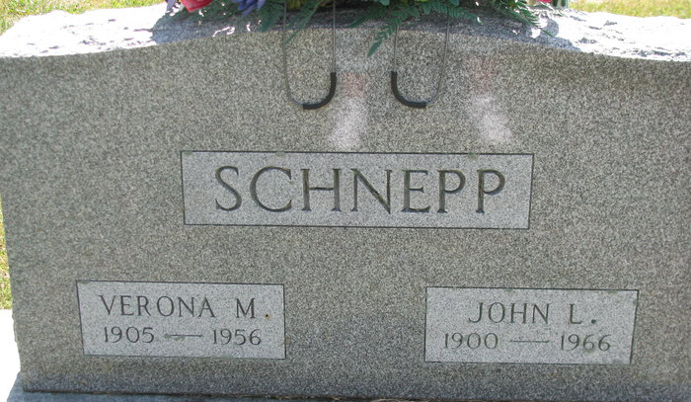
Photo by PLS

John L Schnepp
in the Indiana, U.S., Death Certificates, 1899-2017
Name John L Schnepp
Gender Male
Race Caucasian (White)
Age 66
Marital Status Widowed
Birth Date 26 Apr 1900
Birth Place Indiana
Death Date 20 Nov 1966
Death Place Decatur, Adams, Indiana, USA
Death Registration Date 1966
Father Abe Schnepp
Mother Emma V McGill
Informant: Mrs. Robert Beery; daughter; Decatur, Indiana
Burial: November 23, 1966; Decatur Cemetery; Decatur, Indiana

