Jean Katherine (Carter) Schnepp
July 7, 1926 – December 29, 2013

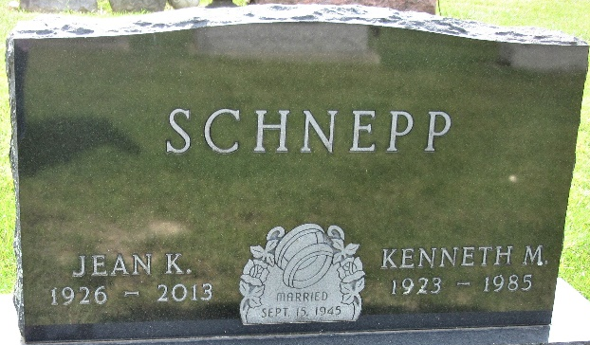
Photo of PLS

Jean Katherine Schnepp, 87, passed away Sunday, Dec. 29, 2013, in Fort Wayne. Born July 7, 1926, in Fort Wayne, she was the daughter of the late Virgil and Evelyn Carter. She married Kenneth Schnepp Sr. in Fort Wayne in September of 1945.
Surviving is her son, Kenneth (Vicki) Schnepp Jr. of Lansing, Mich.; daughter, Tonya of Roanoke, Ind.; grandchildren, Karole (Jimmy) Jenkins, Devin (Megan), Nathan and Nicholas; sisters, Patricia VanRyn, and Nila Ross; and many nieces and nephews. She was also preceded in death by her husband of 40 years, Kenneth Sr.; sons, David, and Greg; and daughter, Carol.
Service is 11 a.m. Thursday at Suburban Bethlehem Lutheran Church, 6318 W. California Road, with calling one hour prior. Rev. Bill Mueller officiating. Burial in Decatur Cemetery.
Memorials may be made to Suburban Bethlehem Lutheran Church.
"The family would like to thank the staff of Kingston Healthcare for their professional and kind care of "Miss" Jean."

D.O. McComb & Sons Funeral Home, Allen County, Indiana
December 30, 2013

**
Jean Katherine Schnepp, 87, of Fort Wayne, IN, and having family members in Roanoke, IN, died Sunday, Dec. 29, 2013. She married Kenneth Schnepp Sr. in Fort Wayne in September of 1945. He preceded her in death after 40 years of marriage.
Survivors include a son, Kenneth (Vicki) Schnepp Jr., of Lansing, MI; a daughter, Tonya, of Roanoke; two sisters, Patricia VanRyn and Nila Ross; and four grandchildren, Karole (Jimmy) Jenkins, Devin (Megan), Nathan and Nicholas.
A service was held on Thursday, Jan.2, 2014, at Suburban Bethlehem Lutheran Church, Fort Wayne.

Huntington County Tab, Huntington County, Indiana
January 2, 2014

