Infant daughter Schnepp
November 26, 1956 – November 26, 1956

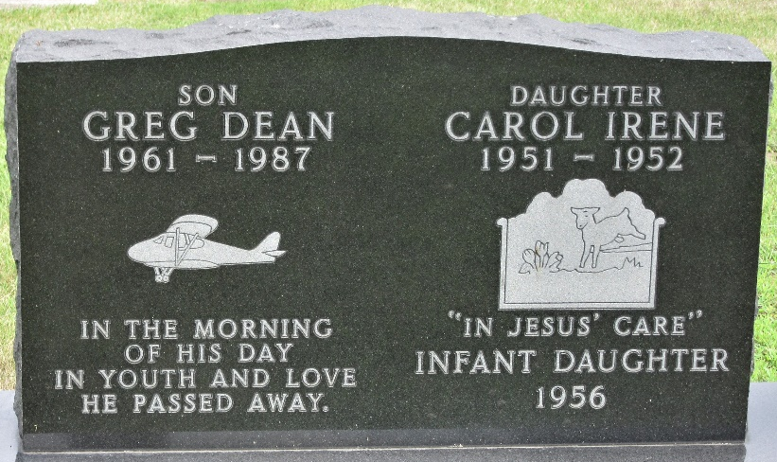
Photo by PLS

Funeral Held Today For Schnepp Infant
The infant daughter of Kenneth and Jean Caston [sic - Carter] Schnepp, of R. R. 10 Fort Wayne on the Hessen Cassel Road, died at the Parkview Memorial Hospital in Fort Wayne Monday at 10:02 a.m., shortly after premature birth.
Surviving in addition to the parents are the grandparents, Ollie Schnepp of Decatur and Mr. and Mrs. Virgil Caston of Paulding Road, Fort Wayne; the great-grandmother, Mrs. Rosa Duff of Willshire, O., and two brothers, Kenneth, Jr., and Michael, at home.
Funeral services were conducted at the graveside in the Decatur Cemetery at 2 p.m. today with the Rev. Lawrence T. Norris officiating. The Zwick Funeral Home was in charge of arrangements.
Decatur Daily Democrat, Adams County, Indiana
Tuesday, November 27, 1956

