Norah Mae (Drake) Schnepp-Hoverman
April 5, 1890 – January 15, 1952

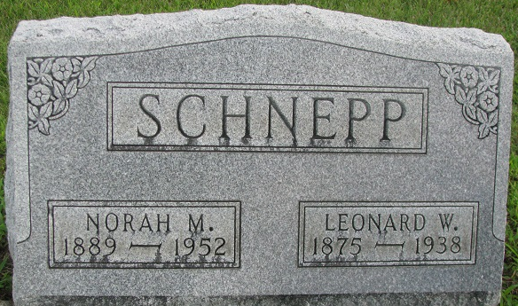
Photo by PLS

Nora Drake Schnepp
in the U.S., Social Security Applications and Claims Index, 1936-2007
Name Nora Drake Schnepp
[Norah M Hoverman]
[Nora Drake Drake]
Gender Female
Race White
Birth Date 5 Apr 1890
Birth Place Decatur, Indiana
Father William Drake
Mother Lunetta Krick
SSN xxx
Notes Jun 1937: Name listed as NORA DRAKE SCHNEPP; Apr 1950: Name listed as NORAH M HOVERMAN
**
Ohio Deaths, 1908-1953

Name Norah Mae Hoverman
Sex Female
Age 62
Birth Date 05 Apr 1889
Birthplace Adam Co., Indiana
Death January 15, 1952
Death Place Van Wert County, Ohio
Race White
Status Married
Father's Name Wm. Drake
Mother: Unknown
Father's Sex Male
Informant Ben Hoverman
Burial: January 17, 1952; Decatur Cemetery; Decatur, Indiana
Source Details certificate
**

Indiana, U.S., Marriages, 1810-2001
Name Norah Drake
Gender Female
Race White
Age 19
Event Type Marriage Registration (Marriage)
Birth Date 5 Apr 1889
Birth Place Adams, Indiana
Marriage Date 20 Jan 1909
Marriage Place Indiana, United States
Residence Place Adams, Indiana
Father William Drake
Mother Luretta Krick
Spouse Leonard W Schnepp
Page 216

