Hermena (Brown) Schnepp
February 11, 1902 – April 20, 1938

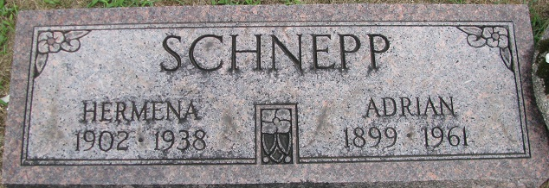
Photo by PLS

Hermena Schnepp
in the Indiana, U.S., Death Certificates, 1899-2017
Name Hermena Schnepp
[Hermena Brown]
Gender Female
Race White
Age 36
Marital Status Married
Birth Date 11 Feb 1902
Birth Place Ohio
Death Date 20 Apr 1938
Death Place Wayne, Allen, Indiana, USA
Death Registration Date 1938
Father Cyrus Brown
Mother: Blossom
Spouse Adrian Schnepp
Informant: Adrian Schnepp
Burial: April 23, 1938; Decatur, Indiana

