Henry G. Schnepp
June 26, 1889 – June 20, 1973

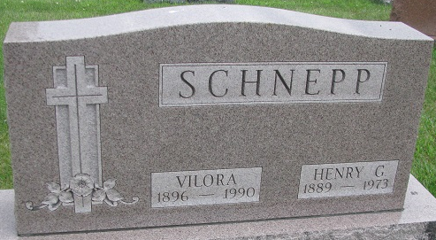
Photo by PLS

Henry G. Schnepp Dies at Hospital

Henry G. Schnepp, 84, of Fort Wayne, died at 4:45 p.m. Wednesday at the Lutheran Hospital. He was admitted Tuesday morning.
He was the son of Frank and Hannah Barrone-Schnepp, and was born June 26, 1889, in Van Wert (O.) county, Mr. Schnepp was married Dec. 25, 1912, to Vilora Miller.
Surviving is the wife, one daughter, Mrs. Walter (Berniece) Henning, Fort Wayne; two grandchildren and one great-grandchild. Two brothers, Val and Charles, preceded him in death.
Funeral services will be held at 1 p.m. Saturday at the McComb Funeral Home, Fort Wayne, with burial in Decatur Cemetery. Friends may call at the funeral home until time of the services.

Decatur Daily Democrat, Adams County, Indiana
Thursday, June 21, 1973

